What is Travelling Salesman Problem?
The Travelling Salesperson Problem (TSP) is an optimization problem where a salesperson must visit a given set of cities exactly once, starting and ending at the same city. The goal is to find the shortest possible route that covers all the cities and returns to the starting point.

TSP is an NP-hard problem, meaning there is no known efficient solution for large datasets, but various algorithms can provide exact or approximate solutions.

Why is TSP Algorithm Important?
The algorithm for salesman Travelling problem is important because it represents real-world problems that many industries face, such as:
- Delivery services need to plan routes to drop off packages at multiple locations.
- Logistics companies need to find the shortest path to transport goods efficiently.
- Manufacturing companies need to reduce the travel of robotic arms in factories.
Solving TSP helps reduce time, fuel costs, and energy, making operations faster and cheaper.

Travelling Salesman Problem: Example
Let's say we have a salesperson who needs to visit four popular Indian cities: Mumbai, Delhi, Bengaluru, and Chennai, and they want to find the shortest route that visits each city exactly once and returns to the starting city.
The distances between the cities are:
 | Mumbai | Delhi | Bengaluru | Chennai
Mumbai | 0 | 1,400 km | 980 km | 1,330 km
Delhi | 1,400 km | 0 | 2,150 km | 2,200 km
Bengaluru | 980 km | 2,150 km | 0 | 350 km
Chennai | 1,330 km | 2,200 km | 350 km | 0
Problem: The salesperson starts in Mumbai and must visit Delhi, Bengaluru, and Chennai exactly once, then return to Mumbai. The goal is to find the shortest route.

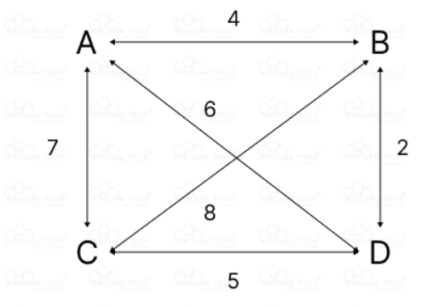
Possible Routes: Let’s calculate the total distance for a few possible routes:

1. Mumbai → Delhi → Bengaluru → Chennai → Mumbai
- Mumbai → Delhi = 1,400 km
- Delhi → Bengaluru = 2,150 km
- Bengaluru → Chennai = 350 km
- Chennai → Mumbai = 1,330 km
Total distance = 1,400 + 2,150 + 350 + 1,330 = 5,230 km

2. Mumbai → Delhi → Chennai → Bengaluru → Mumbai
- Mumbai → Delhi = 1,400 km
- Delhi → Chennai = 2,200 km
- Chennai → Bengaluru = 350 km
- Bengaluru → Mumbai = 980 km
Total distance = 1,400 + 2,200 + 350 + 980 = 4,930 km

3. Mumbai → Bengaluru → Chennai → Delhi → Mumbai
- Mumbai → Bengaluru = 980 km
- Bengaluru → Chennai = 350 km
- Chennai → Delhi = 2,200 km
- Delhi → Mumbai = 1,400 km
Total distance = 980 + 350 + 2,200 + 1,400 = 4,930 km
The shortest routes are:
- Mumbai → Delhi → Chennai → Bengaluru → Mumbai with a total distance of 4,930 km.
- Mumbai → Bengaluru → Chennai → Delhi → Mumbai with a total distance of 4,930 km.
In both cases, the total travel distance is the same, and this is the most efficient route for the salesperson to minimize travel distance.
Key Takeaway:
In this example, we used the salesman travelling problem to determine the shortest route between four major Indian cities. By calculating different possible routes, we found the shortest one, which helps reduce travel time and costs.
However, real-life problems can be much more complex.

